LISTENING
Time: 25 minutes
Task 1
You will hear five short extracts in which people are giving reasons why they use bikes to get to work. For questions 1-5 in the Answer Sheet choose from the list (A-H) the reason each speaker gives. Use the letters only once. There are three extra letters you do not need to use. You will hear the text twice.
A. It’s a safe way to travel.
B. I found driving my car so stressful.
C. I wanted to avoid being in large crowds.
D. It’s a reliable form of transport.
E. I like surprising the people I work with.
F. It helps me to get more work done.
G. I’m helping to keep the environment clean.
H. I bought it to save money.

Task 2
You will hear a journalist called Nina Cooke talking about the impact that technology has had on her family. For questions 1-10, complete the sentences with a word or short phrase. You need to write 1-3 words. You will hear the recording twice.

Technology and me

Of all her domestic chores, (1) ________________________ is one that Nina dislikes most.
Nina has no intention of ever buying (2) ________________________ online.
Nina still buys a newspaper because of the (3) ________________________ provided.
Nina believes that convenience of (4) ________________________ has saved her money.
Nina is impressed by the (5) _____________________ at which teenagers communicate by text.
Nina worries about potential (6) ____________________ when her son is absorbed in his music.
The (7) ____________________ she has gained now the family all own MP3 makes Nina happy.
Nina praises the (8) ________________________ facility on the computer, which allows even young children to work on their own.
The possible implications of the amount of (9) ________________________ required by schools concerns Nina.
YouTube has given access to videos of favourite bands from the (10) ______________________ for Nina’s husband.
Transfer your answers to the answer sheet.

READING
Time: 25 minutes
Task 1
You are going to read a magazine article about working in the music industry. For questions 1-10, choose from the people (A-D). The people may be chosen more than once.
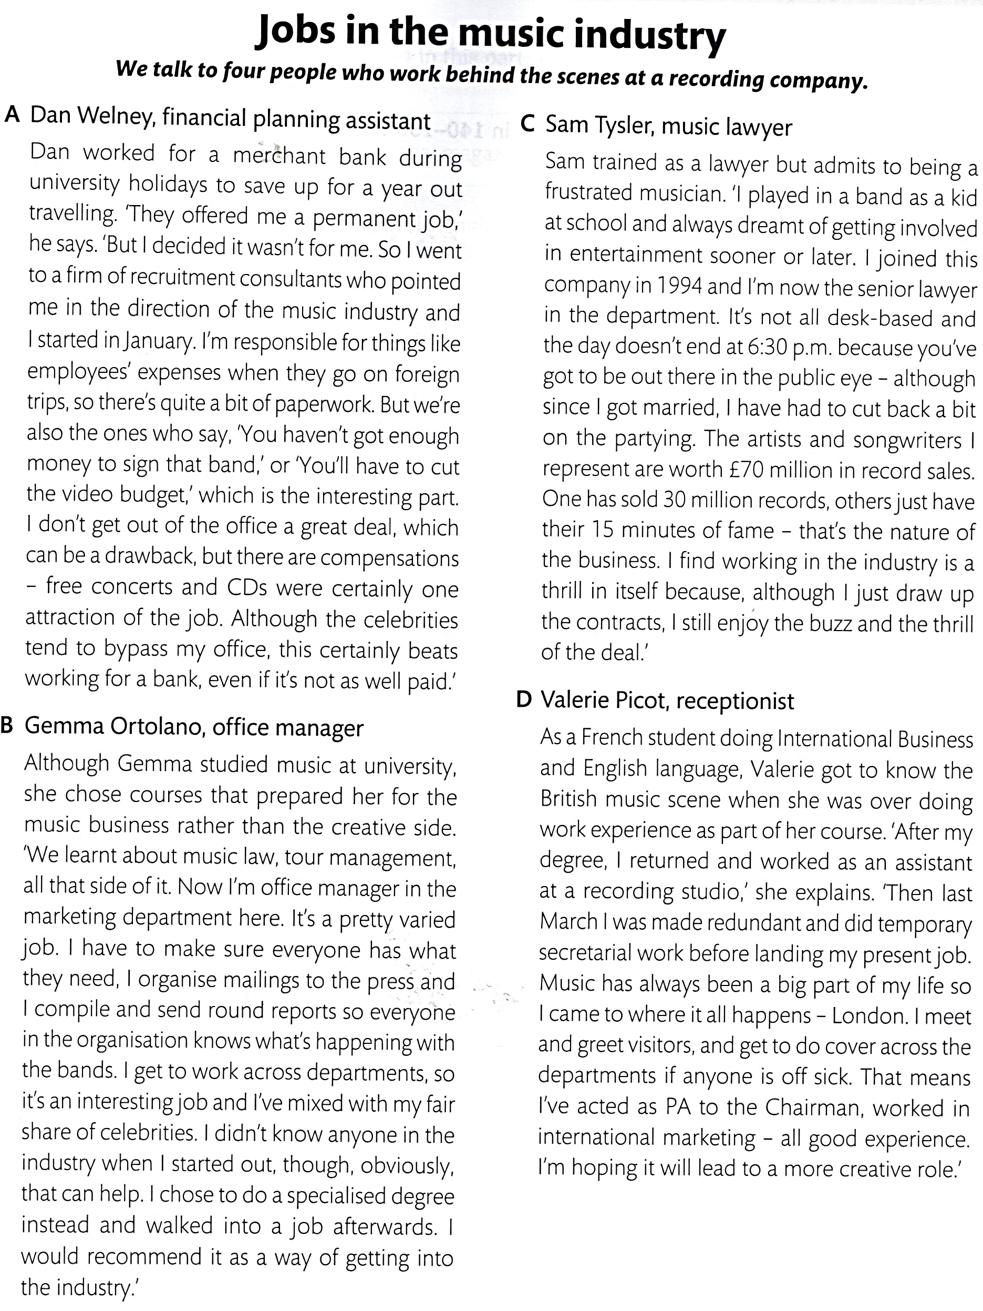
1. ____  2. ____  3. ____  4. ____  5. ____  6. ____  7. ____  8. ____  9. ____  10. ___ | 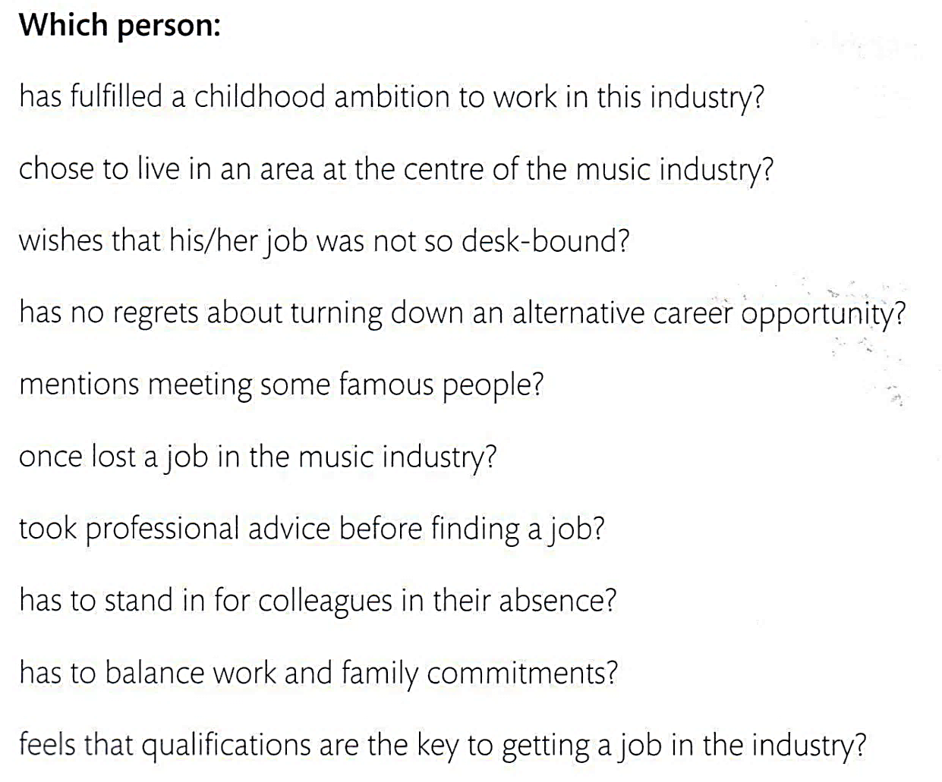
Task 2
You are going to read an article about reading trends in Russia. Some phrases have been removed from the article. Choose from sentences (A-J) the one which fits each gap (11-20).
Printed books are still the most popular format in Russia, but the use of electronic books is rising steadily. The statistics seem to suggest that less people are going to libraries, which in turn are diversifying their services to gain new subscribers and maintain a healthy volume of readers in the country.

According to survey carried out by Public Opinion Foundation this year, despite a rise the popularity of their electronic counterparts, (11)_____________________. However, this is only based on individuals who read at least once a month, and perhaps a more telling statistic is that 37 percent of those surveyed said that they do not read books at all.

Unchanging readership levels
29-year-old Anna Yudina loves to read and always buys books, (12)________________. “I really love going to bookstores or just rummaging through bookstands on the streets,” she says. “I guess it’s the best way to relax. I then have to take them to my grandmother’s because my rented apartment is too small to keep them.” She explains that (13)________________, she is being forced to download more and more electronic books in order to take them on her business trips.
Vadim Mescheryakov, (14)__________________ , explains that the percentage of people who read books has not changed for several generations. “Some of these people buy electronic books, but (15)__________________ ”, says Mescheryakov. According to the publisher, readers today are characterised by their solidarity.
According to Mescheryakov, the number of readers is not affected, such as BookCrossing or Books in the Parks, (16)_____________________. “If a book is well promoted and someone buys it, that doesn’t mean they will go on to read regularly. If someone reads a trash novel, they won’t move on to Dostoevsky.”

Innovating libraries
Besides Internet forums, libraries are the main places where readers can meet up. According to the Public Opinion Foundation’s survey, the number of people visiting libraries (17)___________________, but Lilia Bagrova, (18)___________________, believes that there is actually growing interest in them.
“People are coming to us for information,” she says. “Because of the fragmentation of the information space into specializations, everyone is interested in knowledge integration, and librarians (19)___________________.” According to Bagrova, the Nekrasov Library now serves 9,400 readers annually, up from five to six thousand.
Many Moscow libraries are organizing events to attract readers. “Our library has the advantage of being in an exceptional building, so many people come to see that and then browse the books afterwards,” says Bagrova. “We have a club for book-lovers that meets at the library and one for movie fans. We organize joint events with schools, such as photography and other kinds of exhibitions. There are also approaches that are completely new to us, such as co-working and library tourism, (20)___________________.”

A. has dropped slightly over the last few years
B. where we take people around the library’s collections and explain its history
C. most Russian readers still prefer printed books: 49 percent, as opposed to only 9 percent
D. the director of the Mescheryakov Publishing House
E. have become guides in the world of knowledge
F. even though she lacks the space to store them in her apartment
G. the head of the Nekrasov Library
H. this does not prevent them from reading printed ones
I. where mini-libraries are set up outside
J. despite her passion for printed books

Transfer your answers to the answer sheet.

USE OF ENGLISH Time: 40 minutes
Task 1
For questions 1-8, read the text below and think of the word which best fits each gap.
Use only one word in each gap. There is an example at the beginning (0).
The Edinburgh Festival
If you are interested (0) in the arts, Edinburgh in August is the place to be. Apart from the main International Festival, (1) __________ is what is called ‘The Fringe’, offering 2,700 different shows in over 270 venues throughout the city, many of (2) __________ are free.
Visitors are often surprised (3) __________ the range of shows on offer. This includes comedy, cutting-edge theatre, dance, children’s shows and music. As there is no selection committee, (4) __________ kind of event is possible and the quality varies.
While many high-profile performers take part, the vast majority (5) __________ a mixture of unknown professionals, actors and students, who use the festival as a way of bringing their talents (6) __________ an audience for the first time. Indeed, many well-known comics first appeared there (7) __________ student productions.
In recent years many new audiences have been drawn almost exclusively to stand-up comics and some regular visitors are disappointed (8) __________. However, as a comedy is very much in fashion, they will have to get used to it.

Task 2
For items 9-20, read the text below and decide which option (A, B, C or D) best fits each gap. There is an example at the beginning (0).
Choosing a job
One of the most difficult decisions in choosing what to do for a (0) B. For example, do you want to follow a definite (9) ________________ , and (10) ________________a low
(11) ________________ at the beginning, but have good (12) ________________ in a company that traits its (13) ________________ ? Or are you more interested in taking any kind of work, because you need a / an (14) ________________?
You may have to (15) ________________ the fact that a good job can be difficult to find. In that case, why not take a (16) ________________ one? You will gain some useful experience. Remember that even if you have the right (17) ____________, you may have to (18) _________ lots of application forms before you are asked to (19) ________________ an interview. But don’t worry if you don’t know what you want to (20) ________________ exactly! You’ll enjoy finding out!

0. | A salary | B living | C employee | D work
9. | A company | B training | C business | D career
10. | A earn | B gain | C win | D take
11. | A money | B profit | C cheque | D salary
12. | A hopes | B prospects | C futures | D promotions
13. | A employers | B crew | C staff | D persons
14. | A money | B cash | C account | D income
15. | A face up to | B go over | C come up with | D call off
16. | A temporary | B overtime | C profitable | D short
17. | A qualifications | B exams | C letters | D degrees
18. | A fall through | B get on | C turn down | D fill in
19. | A be | B attend | C make | D advertise
20. | A work | B job | C do | D employ

Task 3
This text includes some words used in American English. Write the British English words on the right-hand size. There is an example at the beginning (0).
It was getting near lunchtime and I needed some (0) gas, so I left the (21) freeway and drove towards the nearest town. There was a petrol station just outside the town and I decided to stop and have a look round. I put the car in a (22) parking lot and took a (23) cab to the centre. It was midday and very hot, so I stopped at a little café with tables on the (24) sidewalk. I started talking to a (25) truck driver, who gave me a history ot the town, and afterwards he took me on a guided tour. I made a very nice break. | 0. petrol  21. _______________  22. _______________  23. _______________  24. _______________  25. _______________

Task 4
Rewrite these sentences using the underlined nouns as verbs. The meaning must say the same. Look at the example first.

(0) We had a long wait. – We waited a long time.

26. There was a lot of rain yesterday.
____________________________________________________________________
27. I had a dream about you last night.
____________________________________________________________________
28. We waited in the queue for half an hour.
____________________________________________________________________
29. The cost of the holiday was about £350.
____________________________________________________________________
30. I wrote a reply to his letter yesterday.
____________________________________________________________________

Task 5
Idioms: moods are weather. Put the following pairs of words into the sentences below:

a. stormed, room | d. given, frosty
b. feeling, weather | e. hazy, do
c. gave, welcome | X

31. We were _______________ a very _______________ reception.
32. He _______________into the _______________ and shouted at me!
33. I’m a bit _______________ about what to _______________ next.
34. They _______________ me a very warm _______________.
35. I’m _______________ a bit under the _______________ this morning.

Transfer your answers to the answer sheet.

WRITING
Time: 30 minutes

Read the problem below. Write your letter of advice. Use 120-140 words.

My cousin has asked me to lend her some money to start an Internet business. You know her, she is intelligent and reliable, and I like her, but she is only 20 years old and does not have much work experience. Also, I know nothing about Internet business. Should I lend her the money?
Please, can you give me some advice?
Stacey

Your answer should include:
1) 2-3 reasons with justifications whether to give money or not and why;
2) 3 different ways to give advice;
3) 2-3 personal qualities of a cousin.

Remember the rules of letter writing. You don’t have to write the address.

Transfer your letter to the answer sheet.

